Dear Customer,

Thank you for your Order. We would like to draw your attention that after checking design file sent by you we have made certain observations and given possible suggestions for the same.

Click here to reply online https://www.pcbpower.com/Pcbpower/sign-in ➔ Exceptions section ➔ Select and reply

Exception: 1
As per gerber data we found datasheet for J20, SW1 But given datasheet part number not match with link given in updated BOM file.
SW1- As per given link- 3*6*2.5 mm SMD Tactile Switch and in description- RS282G05A3
As per datasheet - PTS636 Series - 6.0 x 3.5 Top Actuated

J20- As per given link- Micro USB 2.0 B.and in description- 47346-0001
As per datasheet - 47346-0001

Suggested solution :
Can we consider part number as per below?
J20-RS282G05A3
SW1-47346-0001

Exception: 2
We have found that the manufacture part numbers are missing in your given BOM file. We can not verify footprint with respect to gerber data without manufacture part number.
J17

Suggested solution :
Can we assume that the above parts footprint will match with gerber data? If we found any mismatch after received parts during assembly we will consider those parts as DNP.

Exception: 3
As per exception reply “Gerber Files and Drill Files have been updated” but still we found below problem.
As per gerber data blind drills as per below image are required but, we can not provide such blind-drill combination.
We support maximum 0.30mm end size for blind via but as per Gerber data 0.40mm end size blind via required.
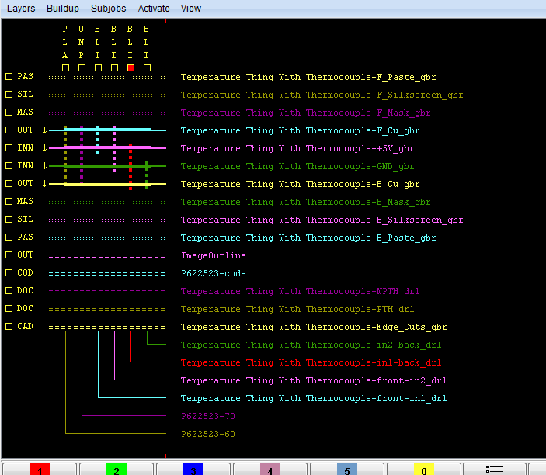

See Next Page.....
We can provide blind via and throgh holes in below cases:
- 1 to 2 , 1 to 3 and 1 to 4
- 1 to 2 , 3 to 4 and 1 to 4
- 2 to 3 , 2 to 4 and 1 to 4

Suggested solution :
We request you to make changes accordingly in gerber data.

Exception: 4
There Can be NO copper or SMD pads within 0.25mm for outer circuit layers and 0.40mm for the inner layers from the PCB edge.
In your design you have Copper area and traces which found overlaped with the pcb contour(outline).
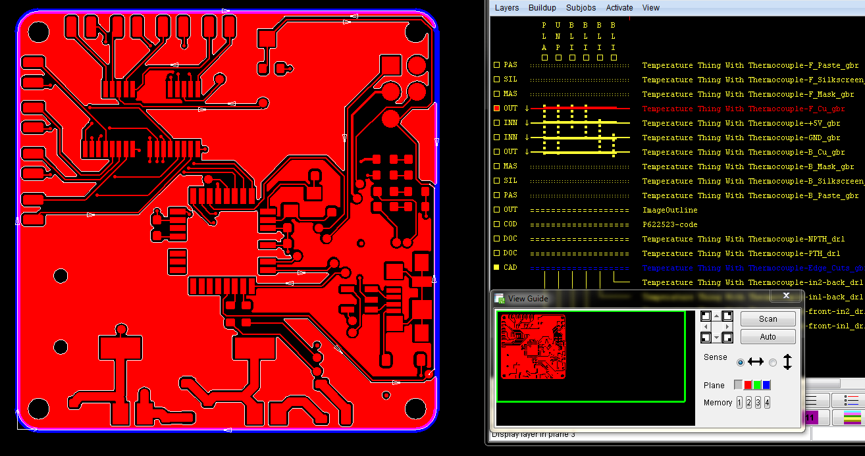

Suggested solution :
We request you to make changes accordingly.

Exception: 5
We found mismatch between Gerber data and Order detail for below mentioned parameters.
PCB parameter | Order details | PCB data specifications | Found in…File name
Special Build-up | No | Yes | Due to Blind Via required.

Suggested solution :
We have consider details given in the Gerber data.
We have modified order detail accordingly to continue the order.
We have recalculated the order price. Please see revised PI to see the price difference.

Give your approval on line as fast as possible!
To review these technical observations as convenient as possible go to https://www.pcbpower.com/ and log into your account. Then proceed as follows:

Select Exceptions Tab to see orders with exceptions :
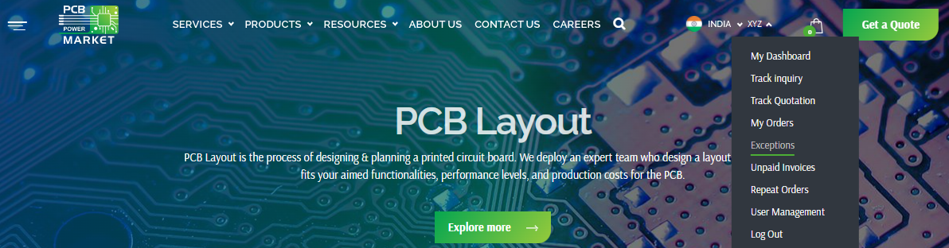

Select an Order Nr and download the exception to see exceptions details :
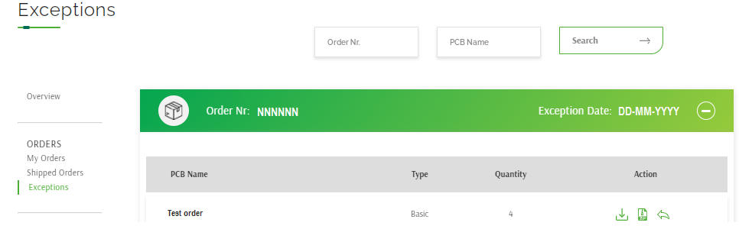

Click on Download button to download our exception file and review it :
* Use New gerber file option to provide modified gerber data :
* Use Exception reply option to provide your feedback in text/word/pdf file – no need to give gerber data again:
*** It is always better to provide all your required remark/feedback into gerber data zip file and reply as a New Gerber file instead of using Exception reply option :
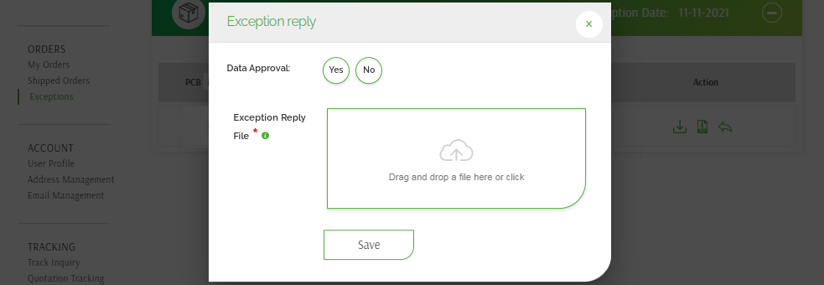

As you submit new gerber data, we will remove previously supplied gerber data. And consider this gerber data only for further process.

Please note that ship date will change based on the working days and the time that is taken by you to resolve the exception.
PCB Power’s Capability:

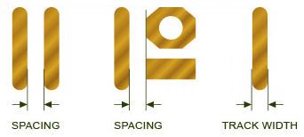
Circuit Layer:
 |  | Outer Layers | Inner Layers
For finished copper thickness of 1.0 Oz/35.00micron. | Min. Track width | 0.09 mm | 0.125mm
For finished copper thickness of 1.0 Oz/35.00micron. | Min. Spacing | 0.09 mm | 0.125mm
For finished copper thickness of 2.0 Oz/60.00micron. | Min. Track width | 0.125 mm | 0.175mm
For finished copper thickness of 2.0 Oz/60.00micron. | Min. Spacing | 0.125 mm | 0.175mm
For finished copper thickness of 3.0 Oz/95.00micron. | Min. Track width | 0.175 mm | 0.21mm
For finished copper thickness of 3.0 Oz/95.00micron. | Min. Spacing | 0.175 mm | 0.21mm

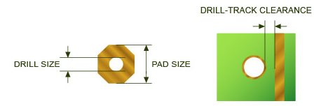

Drilling:
Minimum finished via drill size | 0.100 mm
Minimum annular ring – Outer layers | 0.105 mm
Minimum annular ring – Inner layers | 0.125 mm
Minimum via pad size – Outer layer | 0.460 mm
Minimum via pad size – Inner layer | 0.500 mm
Drill to track clearance for inner layer (up to 6-layer) | 0.250 mm

